Power Save - Tickless Mode

Materials

* AmebaD [ [AMB23](https://www.amebaiot.com/amebad/#rtk_amb23) / [AMB21](https://www.amebaiot.com/amebad/#rtk_amb21) / [AMB22](https://www.amebaiot.com/amebad/#rtk_amb22) / [BW16](https://www.amebaiot.com/amebad/#partner_bw16) ] x 1

Example

**Introduction**

Ameba-D supports two low power modes which are deepsleep mode and sleep mode. The power consumptions of Tickless Sleep Mode is around 28uA to 30uA compared to normal state around 15mA. This example describes how to use freertos tickless with UART interruptable interface.

**Procedure**  
Open “File” -> “Examples” -> “AmebaPowerSave” -> “TicklessMode”

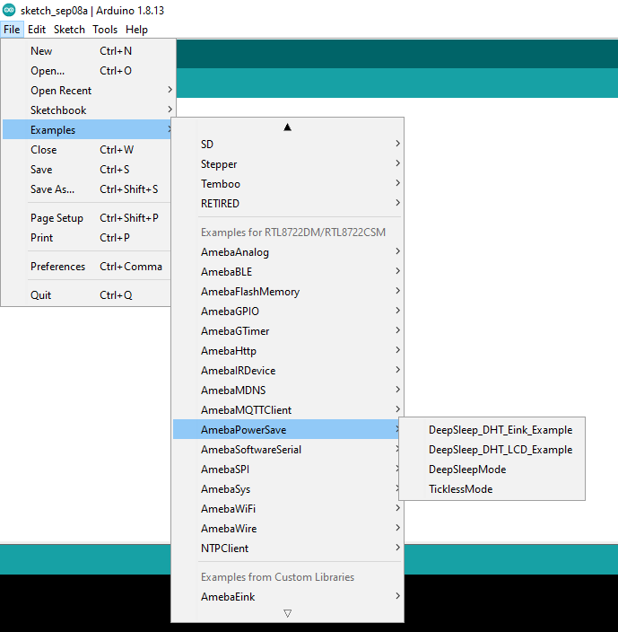

Set condition values as picture below.  
“TL_WAKEUP_SOURCE” is used to set the wake-up source, user can chose 3 wake up sources now,  
LOGUART(SET_TL_UART_WAKEUP);  
RTC Timer(SET_TL_RTC_WAKEUP);  
AON pins(SET_AON_WAKEPIN_WAKEUP);

Using LOGUART as wakeup source  
When the LOGUART is selected as the wakeup source, the “TL_Suspend_function” will enter sleep mode. And then it is kept alive for 13s then enter sleep mode. To wakeup, press enter.  
Using RTC Timer as wakeup source  
RTC Timer wakeup system is by setting alarm. The alarm has 4 values to be set, day, hour, min and sec. All 4 values can be set by DS_RTC_ALARM_DAY, DS_RTC_ALARM_HOUR, DS_RTC_ALARM_MIN, and DS_RTC_ALARM_SEC.

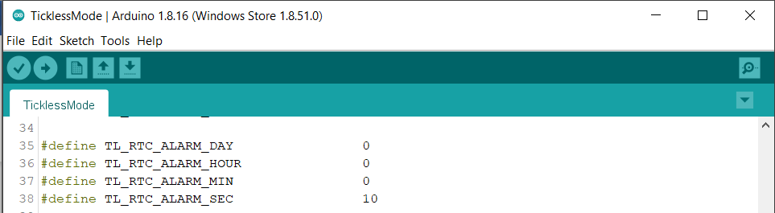

Using AON GPIO pins as wakeup source  
For AMB21, there are 5 pins that can be set as AON pins and active high for wakeup, GPIOA25(D16), GPIOA26(D17), GPIOA21(D26), GPIOA20(D27), GPIOA(D28).

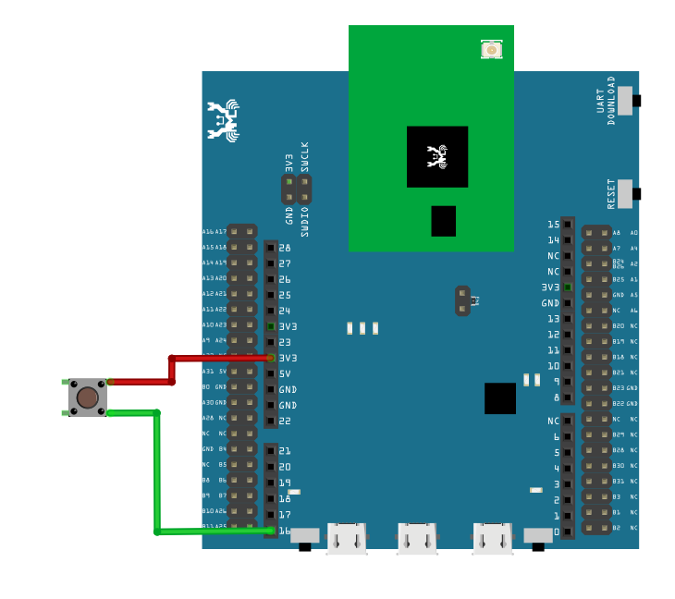

For AMB23, there are 8 pins that can be set as AON pins and active high for wakeup, GPIOA12(D9), GPIOA13(D10), GPIOA14(D11), GPIOA15(D12), GPIOA16(D13), GPIOA18(D15), GPIOA19(D16), GPIOA21(D18).

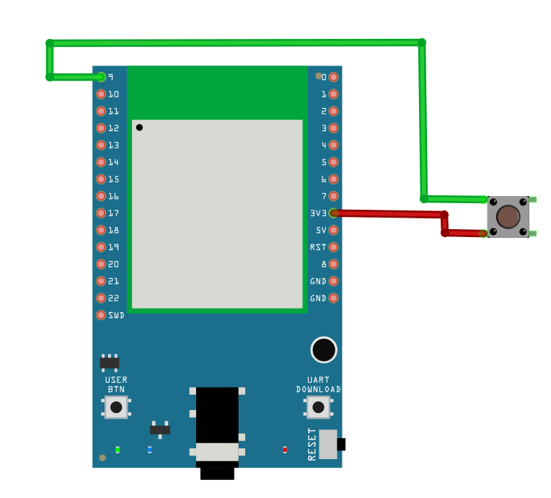

For BW16/BW16-TypeC, there is only 6 pins that can be set as AON pin and active high for wakeup, GPIOA_25 (D7), GPIOA_26 (D8), GPIOA_15 (D9), GPIOA_14 (D10), GPIOA_13 (D11), GPIOA_12 (D12).

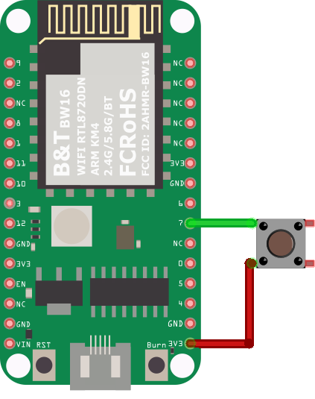

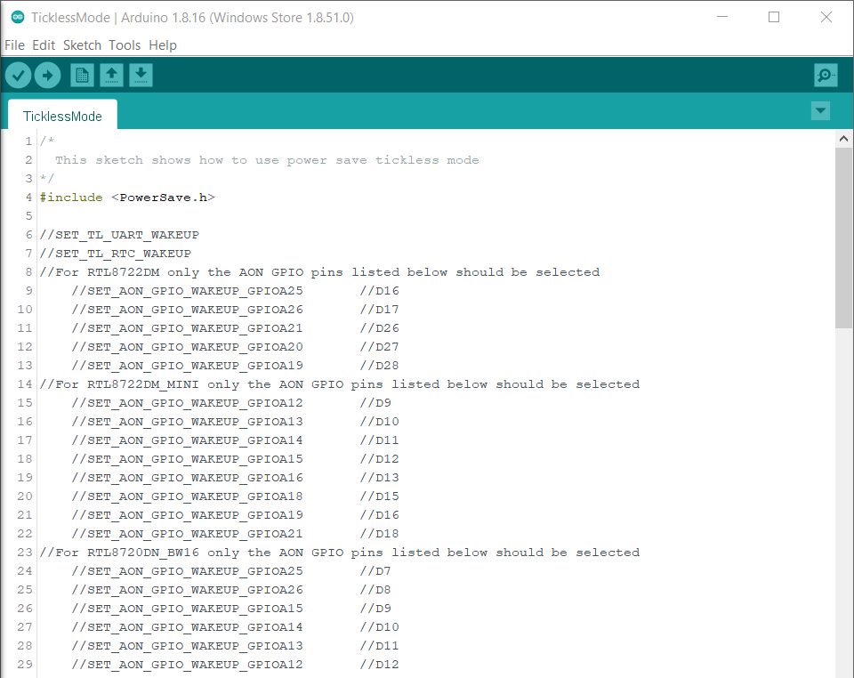

TL_SYSACTIVE_TIME is for setting time duration of the system to keep alive. (Unit ms)

**LOGUART**

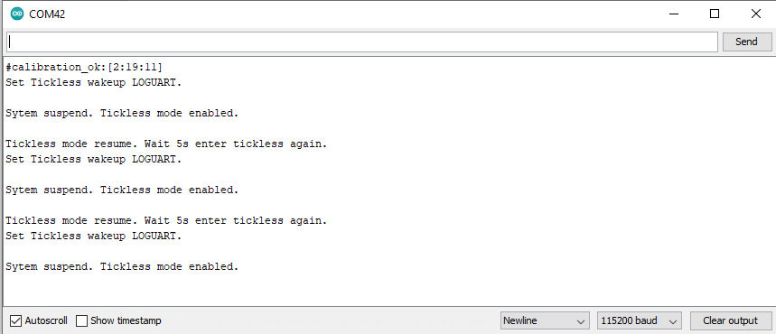

**RTC Timer**

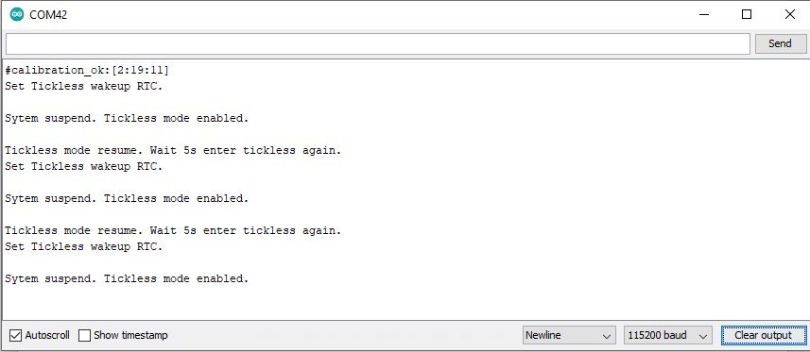

**AON GPIO Pins**

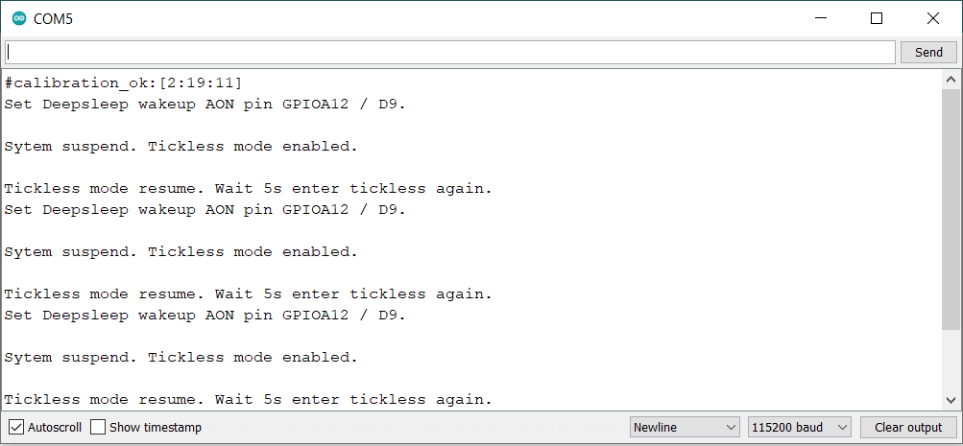

Code Reference

Please refer to the [API Documents](https://www.amebaiot.com/rtl8722dm-arduino-online-api-documents/) PowerSave section for detail description of all API.